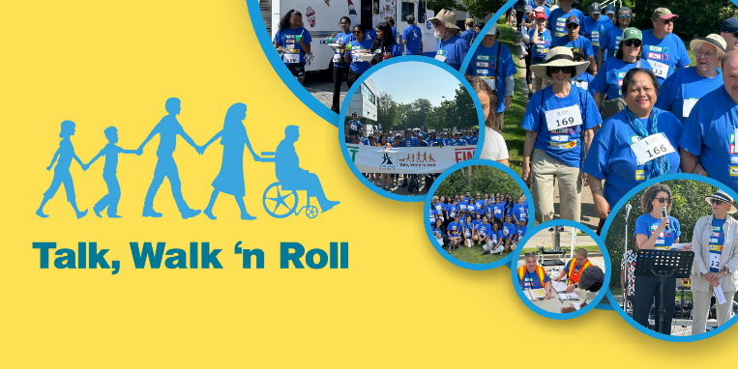

SOCIAL MEDIA TOOLKIT
Images
To use any of these 3 images in your social media post, click on the picture thumbnails below to be taken to the full-size, downloadable version.
Image 1
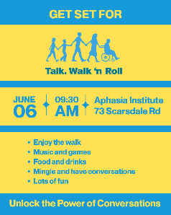

Image 2
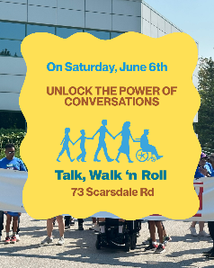

Image 3


Here are some captions you can use:
1. Join me in this year's #TalkWalkNRoll with [tagging Aphasia Institute] to make a real difference in lives impacted by #aphasia.
2. I’m participating in this year's #TalkWalkNRoll with [tagging Aphasia Institute]. Help me make a difference and sponsor me—or join in—today!
3. I’m raising money and awareness for #aphasia and invite you all to join me! Sponsor me in this year’s #TalkWalkNRoll.

4. Did you know that there are over 100,000 Canadians living with aphasia? Sponsor me in this year’s #TalkWalkNRoll to make a real difference in the lives of those impacted by #aphasia.

Tag us on Instagram: @aphasia_inst

Tag us on Facebook: @Aphasia Institute
Tag us on LinkedIn: @Aphasia Institute
Tips & Tricks
- Remember to add your personal fundraising website to the end of your post so that people can head to your site and donate. Need help setting that up? Send a note to talkwalk@aphasia.ca, and we can help you out!

- Use Hashtag; you can always create your own custom post if you like. Just remember to use the hashtag #TalkWalkNRoll to join in the conversation online. We look forward to seeing your posts!

